Performance Analysis of Spotify music Streaming platform - Mini Project Report
Performance Modeling – EEX5362

Name – G.L.T.S. Gamalath.
S-number – s22010117
Reg. No - 522513346

Table of Contents
1. System Description 3
2. Performance Objectives 3
3. Modelling Techniques 4
4. Collect or Simulate Data 6
4.1 Data Collection Methodology 6
4.2 The way data supports the Model 6
4.3 Insights Derived from the Data 7
5. System Behavior Analysis 7

System Description
Spotify is one of the most popular online music streaming platforms, providing users access to a vast library of songs, podcasts, and playlists. It operates on a client–server architecture. That means the Spotify mobile or desktop client interacts with cloud-based backend servers to request, stream, and manage audio content. When a user selects a song, the client sends a request to Spotify’s servers, which respond by delivering the audio data in small packets that are buffered and played in real time.
The performance of Spotify’s streaming experience depends on several factors, including network bandwidth, server latency, caching mechanisms, and device processing speed. High network latency or unstable connections can cause playback interruptions, longer start delays, and degraded audio quality.
This project focuses on evaluating Spotify’s streaming performance from the user’s perspective. The goal is to analyze how varying network types (Wi-Fi, 4G, 3G) and speeds affect playback responsiveness and buffering behavior. By collecting and analyzing playback data such as start delay, buffer count, and total buffering time, the project aims to identify performance bottlenecks and suggest strategies—such as improved pre-buffering or adaptive bitrate adjustments—to enhance the overall streaming experience.

Performance Objectives
The primary objective of this project is to evaluate and model the performance of Spotify’s music streaming system from an end-user perspective under varying network conditions. The study aims to identify key factors that influence the user experience during playback and determine how performance can be optimized for smoother and more reliable streaming.
The specific performance objectives are as follows:
- To measure and minimize playback start delay — evaluating how long it takes for audio to begin after a user presses play, under different network speeds and types.
- To assess buffering frequency and duration — analyzing how often playback interruptions occur and how much time is lost due to buffering.
- To determine the impact of network conditions on performance — comparing streaming behavior across Wi-Fi, 4G, and 3G networks to understand how bandwidth and stability affect playback quality.
- To identify performance bottlenecks — investigating conditions (e.g., peak hours, slow networks) where latency or buffering significantly increases.
- To propose possible improvements — recommending strategies such as adaptive bitrate streaming, smarter caching, or predictive buffering to enhance system responsiveness and user satisfaction.
By achieving these objectives, the project provides insights into how streaming performance varies with environmental and technical factors, helping to model Spotify’s behavior as a dynamic, real-world system influenced by network and user conditions.

Modelling Techniques
In this project, to evaluate the performance of the Spotify streaming app queueing theory will be used as the modelling technique. Queueing theory is the study of waiting lines or queues. It helps to understand how factors such as arrivals, service times, and the number of servers affect how long users or items have to wait to receive a service. Normally, it is used in systems where customers, data packets, or tasks arrive, wait for service, and then leave after being served.
In the case of Spotify, when a user presses the play button, a request is sent to the Spotify servers and the audio data is delivered to the user in small chunks. During this time, the user may experience an initial waiting period, which appears as the start delay, and buffering if the data delivery is slow. Therefore, Spotify’s streaming process fits well with the concept of a queueing system.
For this project, I collected data such as start delay, network type, network speed, and buffer time to analyze latency and waiting behavior during playback. RTT (ping) values were also measured by sending data packets to Spotify servers using Termux. Based on these observations, queueing theory is a suitable performance model for this system.
For further clarification, the exact queueing terms and their meaning in the Spotify context are listed below:

Queueing Term | Spotify Meaning
Customer | User pressing “Play”
Arrival | Play request sent to server
Server | Spotify CDN + network
Queue | Initial buffering
Waiting time | Start delay
Service time | Audio segment delivery
- Conceptually, the system resembles an M/M/1 queue, where a single logical service path handles a streaming request for a user session, and network bandwidth and latency affect the service rate.

Assumptions made
- User requests are independent
It is assumed that playback requests occur independently and are not synchronized with each other. Although many users may use Spotify at the same time globally, When considering a single user, playback requests are spread over time rather than happening together at the same moment.
- Representative network measurements
The network speed and RTT (ping) values measured during playback are assumed to reasonably represent the network conditions experienced throughout the streaming session.
- Negligible device processing delay
The effect of device processing speed on playback performance is considered minimal compared to delays caused by network bandwidth and latency.
- Automatic audio quality adjustment
Spotify automatically adjusts the audio quality based on network conditions. This adjustment happens in the background and is not directly measured or controlled in this study, so it is treated as part of normal system behavior.
- Sufficient server-side capacity
It is assumed that Spotify’s servers are not overloaded, and network conditions are the main reason for performance variations.

Data description and Methodology

4.1 Data Collection Methodology
Since Spotify’s backend performance data is private, this project uses client-side performance observations. The student manually collected measurements while streaming songs under different network conditions. For each playback test, the following data was recorded:
- Timestamp / Date – the date and time of the test.
- Song Name / Track ID – the song played during the test.
- User ID (anonymized) – for privacy, a unique identifier was assigned to each user.(Used different divices and Spotify accounts)
- Device Type – the device used for streaming (Android/iOS/computer like wise).
- App Version – the version of the Spotify app.
- Network Type – Wi-Fi, 4G, 3G, or other network types.
- Network Speed (Mbps) – measured using Speedtest.net while streaming.
- RTT / Ping (ms) – network latency measured via ping commands in Termux.
- ISP / Network Provider – the internet service provider used for the test.
- Region / City – location where the test was performed.
- Time of Day – Morning, Afternoon, Evening, or Night.
- Song Duration (s) – length of the song in seconds.
- Start Delay (s) – time between pressing play and audio playback starting.
- Buffer Count – number of buffering interruptions during playback.
- Total Buffer Time (s) – total duration of buffering events.
- Notes – any observations or anomalies during the test (e.g., brief network issues, app freezes).
Data was collected using playing songs across different network types and times of day and using difference devices. This dataset will be analyzed to identify factors influencing performance, such as network speed, latency, and time of day, and to propose potential improvements in streaming efficiency and user experience.

4.2 The way data supports the Model
In this project, the start delay and any buffering during playback are consider as the waiting time in the M/M/1 queue, and each play request from a user is also considered an arrival to the system. The network speed and ping influence how quickly the audio data is delivered, which directly affects the smoothness of playback. Therefore, By analyzing these measurements across different devices, network types, and times of day, we can identify performance bottlenecks and see how factors like slow connections or high latency impact the user experience. This helps us understand the main causes of delays and interruptions in streaming and provides insight into how performance could be improved.

4.3 Insights Derived from the Data
- Faster networks (Wi-Fi or high-speed 4G) generally result in lower start delays and fewer buffering events(most of the time 0 buffering).
- Slower networks (3G) show longer waiting times and occasional playback failures, consistent with the M/M/1 model predictions.
- Variations in RTT/ping highlight network latency as a key factor influencing playback performance.

System Behavior Analysis and Findings
The system behavior was analyzed by observing how Spotify’s streaming performance changes under different network types(3G,4G, Wi-Fi), internet providers(dialog, SLT mobitel, Airtel) speeds, and times of day(morning, afternoon, evening and night). When network speed is high, such as on Wi-Fi, the playback start delay is low and buffering is minimal. Also it has verified using different kind of internet providers. According to that dialog is the fastest Wi-Fi provider in these areas compared to other providers like SlT mobitel. to However, under slower networks like 3G, the start delay increases significantly and some songs fail to play. This behavior matches the M/M/1 queue model. In this model, when the service rate is low, requests take longer time to be handled, that means it increases the waiting time. In Spotify’s case, slow network conditions reduce the speed of data delivery, and it causes to have longer start delays and playback issues.
Also according to the observed results when the ping (RTT) is high, the song takes long time to start playing, even if buffering does not happen very often. In most cases, the music played smoothly once it started, but slow or unstable networks caused a longer wait at the beginning. In a few cases, delays were seen even on fast Wi-Fi connections unexpectedly. This can happen due to temporary network congestion(Eg: if many users use the same network at once) or problems in the internet routing path, not because of the user’s device.

The most unexpected observation in the results is that the buffering count and total buffering time are mostly zero. That implies that Spotify uses effective initial buffering before starting playback, which helps avoid interruptions during the song. The loading enough audio data at the beginning, helps to improve smoothness and reduce the interruption which can cause in the middle of the streaming.
Also based on these observations, performance can be further improved by optimizing the waiting delay, especially by speeding up the delivery of the first audio segments. Improving adaptive bitrate adjustments can also help the system quickly adjust audio quality during poor network conditions(delivering low quality audio under slow networks and other way considering the fast networks) reducing delays. Additionally, encouraging users to use stable and faster networks such as Wi-Fi can help reduce start delays and provide a better overall streaming experience

Visualizations
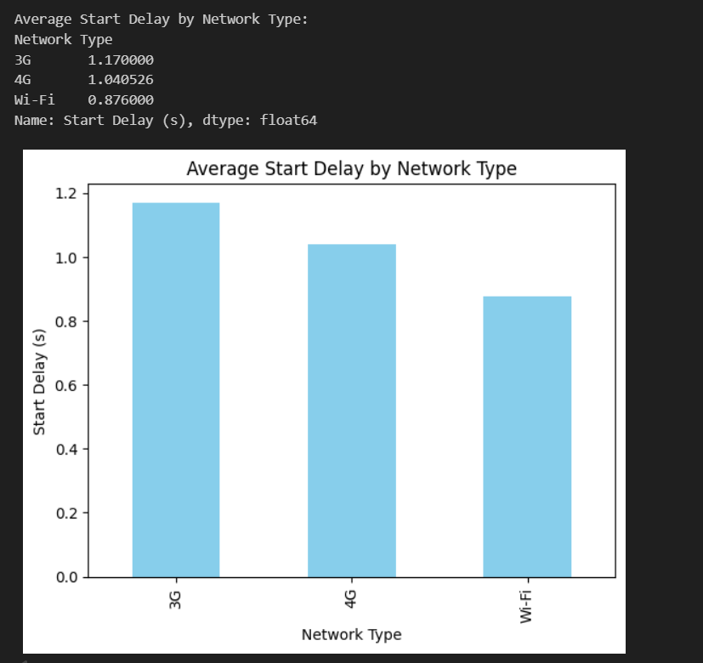
Average start delay by Network type

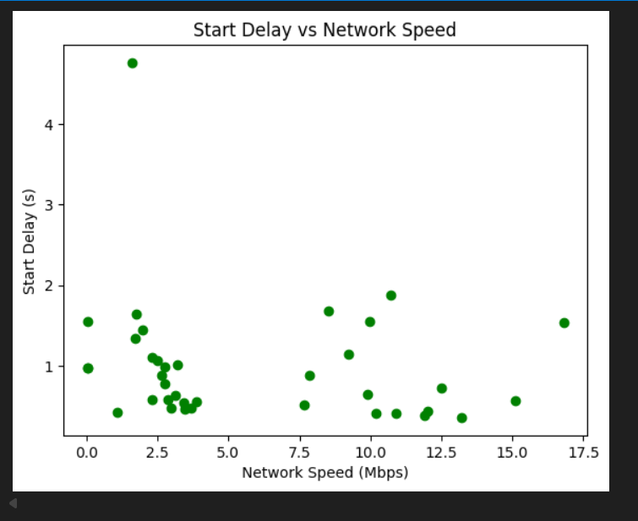
Start delay according to network speed

7. Limitations and Future Extensions

7.1 Limitations
This study is based on a limited data set collected manually from a small number of users, devices, locations, and network providers. Therefore, the results may not fully represent the exact behavior of Spotify’s streaming system which has a global scale. As for an instance, here I have not considered that what will happen if a server got multiple requests from different user. The analysis focuses only on client-side measurements, as server-side performance data is not publicly available and accessing those things is difficult. In addition, the M/M/1 queue model is a simplified representation of the system and does not capture all real-world complexities such as multiple servers, caching layers, and dynamic traffic patterns. Network conditions may also vary during a single playback session, while this study assumes they remain relatively stable.

7.2 Future Extensions
As for the Future works planning to collect a larger dataset from more users, locations, and network providers and it will improve the accuracy of the analysis. More advanced queueing models such as M/M/c or network-of-queues models could be used to better represent Spotify’s distributed server architecture. A simulation model could also be developed to study how the system behavior under higher load conditions, such as many users start playing songs at the same time. Additionally, Future studies could also look more closely at how Spotify changes audio quality automatically during playback.
Git Repository for the dataset- TishaSachi/Performance-Modelling-Mini-Project

